Name ____________________________________________________ Date___________ Hr

8 Things You Need To Know About Durian Fruit: The World’s Smelliest Fruit
If you’ve never traveled to Southeast Asia, it’s possible that you have never encountered fresh durian fruit, the infamous and healthy but divisive Southeast Asian snack that is popular in the region. However, once you have tasted the stinky fruit, it is an experience you are not likely to forget. It has a unique appearance and an even more memorable smell. Durian fruit is generally slightly oval, about a foot wide and covered in formidable looking spikes. The fruit can weigh between two to seven pounds, and this is heavy enough that in holding it in your hands by the body of the fruit, instead of the stem, it could potentially pierce the skin. However, its otherworldly appearance is dwarfed by another one of its attributes – the smell. Durians have a strong, rank smell that permeates the outer shell. 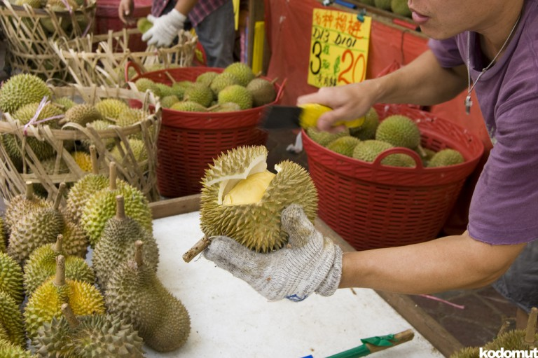
It’s unwelcome in public
Due to its overpowering smell, durian has been banned on many types of public transport across Thailand, Japan and Hong Kong. In Singapore, the fruit is banned across all types of public transportation and even taxis have signs to let you know they refuse to carry passengers transporting the smelly fruit. Hotel rooms and train stations also ban the fruit.

It’s a superfruit

Despite the stench, durian is extremely healthy, even more so than many other fruits. Naturally rich in iron, vitamin C, and potassium, durian improves muscle strength, skin health and even lowers blood pressure. Furthermore, one small durian contains 23g of dietary fiber which is nearly all of your daily nutritional requirement. However, it is important to not eat them in excess, as in 2010 Malaysian politician Ahmad Lai Bujang was rushed to hospital complaining of breathlessness and dizziness after gorging himself on durian.
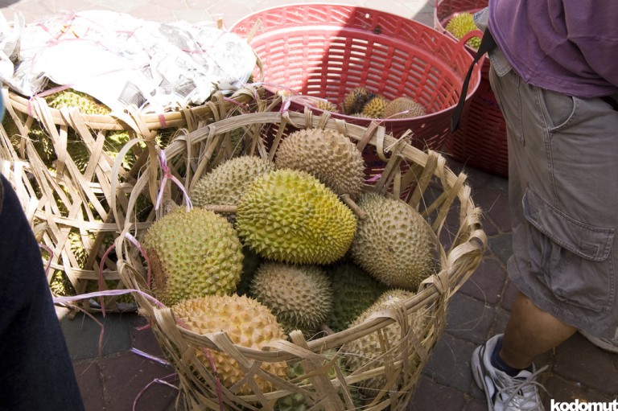
Young vs old
The fruit changes significantly over a very short period of time. When it is harvested early, it is almost considered a vegetable because the flesh is hard, easy to handle and bitter, rather than sweet. People who enjoy eating durian usually prefer the fruit to be over-ripened, when the citrus and sweet flavors are much more prominent. Although the fruit becomes messier by that point with a consistency that is comparable to that of sour cream. Traditionally, durians are eaten after they have fallen to the ground on their own accord, however, durian farms often harvest the fruit earlier in order to ship them overseas.

There’s more than one type
There are around 30 different varieties of durian. The fruit is native to Malaysia, Indonesia and Borneo however today there are durian farms in Sri Lanka, Southern India, Cambodia, Vietnam, Thailand and the southern Chinese island Hainan. Thailand is in fact the biggest exporter of the fruit and home to many durian farms which produce more varieties than the original native locations.
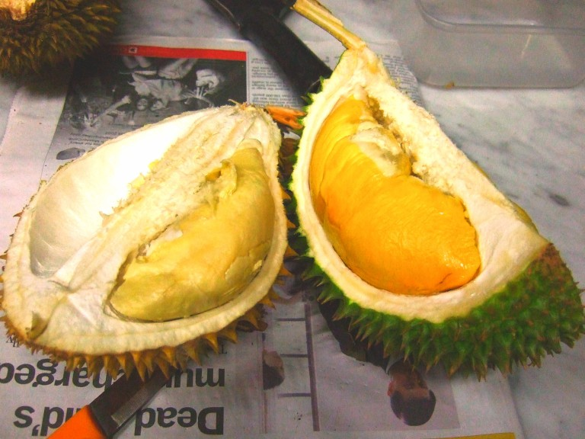

It’s almost impossible to describe the taste and smell
For over a hundred years, travel writers have tried to describe the taste and smell of durian and still we’re nowhere closer to being able to describe it helpfully to someone who has never experienced its unique taste and smell. In 1856, Alfred Russel Wallace sent a letter to Sir William Jackson Hooker describing the fruit as: ‘A rich custard highly flavored with almonds gives the best general idea of it, but there are occasional wafts of flavor that call to mind cream-cheese, onion-sauce, sherry-wine, and other incongruous dishes’. Anthony Bourdain, who actually enjoys eating the stinky fruit, colorfully describes the aftermath of eating it: ‘Your breath will smell as if you’d been French-kissing your dead grandmother’.

It inspires architecture
Singapore’s official fruit is the durian. The Esplanade building next to Marina Bay, started as two glass domes but when the design was altered to include covering the buildings with pointed aluminum shades, the buildings took on the appearance of a durian that has been cut in half.
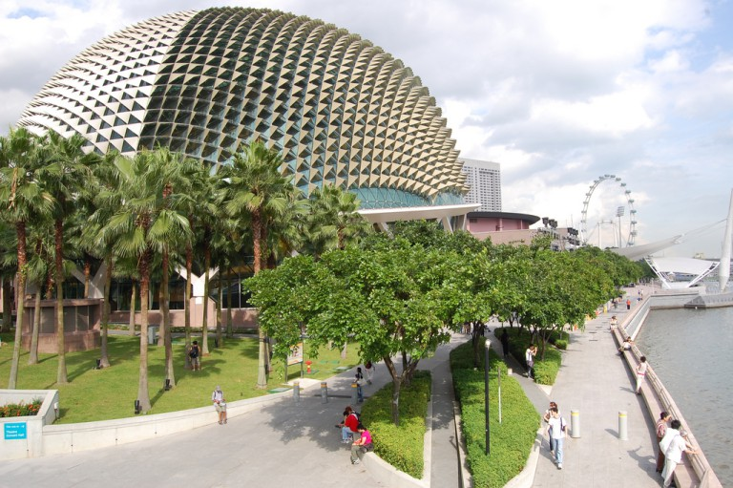

It’s the king of fruit
Whether due to its size – the fruit can weigh as much as 7 pounds – or its taste, durian is often referred to by people in Southeast Asia as the king of fruit. Due to the difficulty of cultivating durian – besides being dangerous when it falls, it requires very particular components in the soil, and for shipping, durian is easily the most expensive fruit as well. Durian deaths are very common. This happens when the fruit falls on a persons head.
The Chinese consider durian and mangosteen to be the king and queen of fruits because of their opposing flavours – the durian is ‘warming’ due to its pungent smell and rich consistency however the mangosteen is ‘cooling’ because of its juicy flesh and slightly acidic taste.
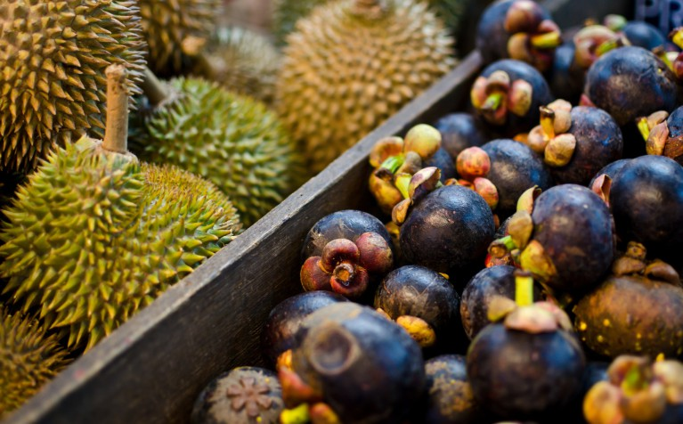

Durian Myths and Tales
The Durian fruit has an interesting tale that accompanies its polarizing attributes. The tale talks about an old, ugly king who although powerful, was unable to win the love of his young bride who constantly refused him. He consulted a hermit, who asked for three peculiar ingredients.
The hermit gave the mixture of the three ingredients to the king and asked him to plant it in the palace garden. From these three ingredients emerged the Durian tree. As soon as the bride ate the fruit of the tree, she was charmed by the king.
However, the king forgot to invite the hermit for the later celebrations, which conduced the hermit to curse the fruits borne by the tree. He replaced the aromatic fragrance by rotten odor and replaced the smooth surface by thorny humps.
World Durian Festival
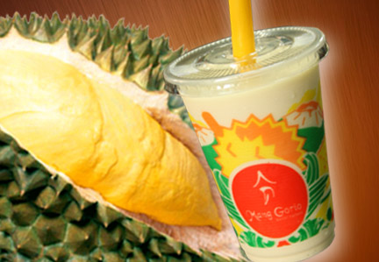
Thailand is the largest producer of Durian in the world. This fruit is so popular in Thailand that a nine-day festival is also carried out in its honor, in Chanthaburi province during the month of May. Chanthaburi province touts to have the largest number of Durian orchards in the world. This festival features parades of carnival floats, Durian-eating competitions and demonstrations of various Durian-dish preparations. Various other local produce are also displayed in this festival. Durian shakes are popular at the festival. Moreover, Durian chips, made by the same process as potato chips are also prepared at the festival, which are fun to watch. You can also get the chance to taste the different varieties of Durian available.

Name____________________________________________ Date___________________ Hr_____

Durian the Smelliest Fruit in the World Questions
- In what three countries has Durian fruit been banned?
- Where exactly is the fruit banned in public?
- What nutrients are Durian rich in?
- What are the health benefits of Durian?
- Traditionally, when are Durians eaten?
- How many varieties of Durian exist?
- What is the fruits origin?
- Which country is the biggest exporter of Durian?
- How does Anthony Bourdain describe the fruit?
- What city is the Durian the official fruit of?
- What two architectural buildings were inspired by Durian?
- How much can one Durian fruit weigh?
- What types of Durian dishes are served at the Durian festival?

